Project Design Phase
Solution Architecture

Date | 2 February 2026
Team ID | LTVIP2026TMIDS65523
Project Name | Gemini Historical Artifact Description
Maximum Marks | 4 Marks

Solution Architecture:
Solution architecture is a complex process with many sub-processes that bridges the gap between business problems and technology solutions. Its goals are to:
- Find the best tech solution to solve existing business problems.
- Describe the structure, characteristics, behavior, and other aspects of the software to project stakeholders.
- Define features, development phases, and solution requirements.
- Provide specifications according to which the solution is defined, managed, and delivered.

Example - Solution Architecture Diagram:

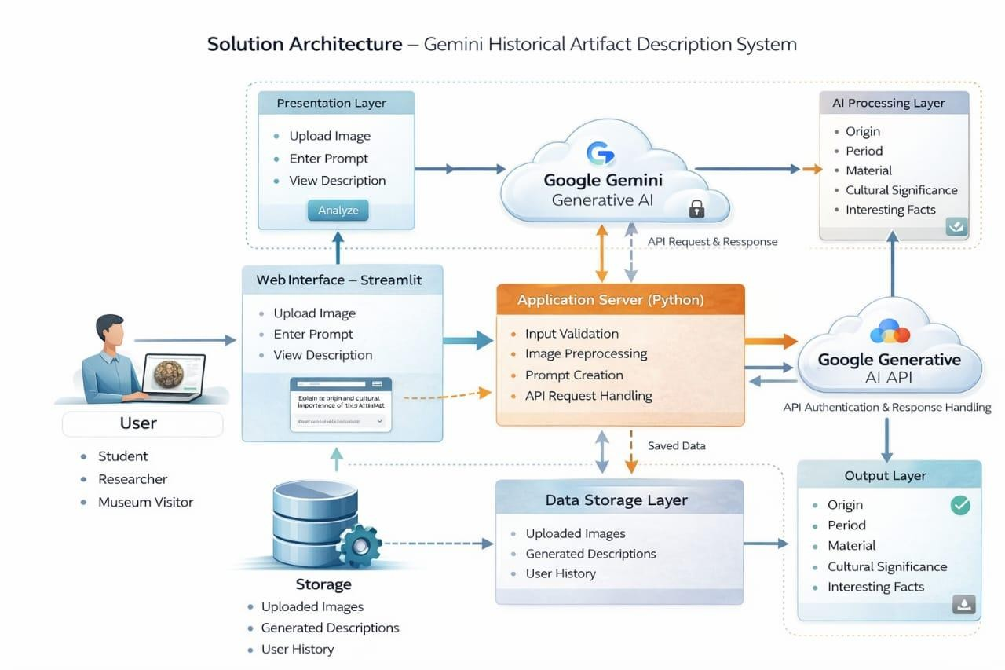
Step-by-Step Working:

Step-1: User opens the system
- The user (student / museum visitor / researcher) opens the web or mobile application and logs in.
- The system shows a camera/upload option.

Step-2: Capture or Upload Image
The user takes a photo of a historical artifact (statue, coin, temple carving, weapon, inscription) or uploads an existing image from the gallery.

Step-3: Image sent to Backend Server
- The application sends the image to the backend server through the internet (API request).
- The server receives the image and prepares it for processing.

Step-4: AI Image Analysis (Gemini / Vision Model)
- The AI model analyzes the picture:
o detects object type o identifies material (stone, bronze, gold, etc.) o recognizes historical period o finds symbols or text
- This is the main brain of your project.

Step-5: Historical Knowledge Retrieval (Database)
After identification, the server checks the historical database:
- monument details
- dynasty/kingdom
- usage and purpose
- location and cultural importance

Step-6: Generate Description (Generative AI)
Gemini AI generates a human-readable explanation like a museum guide:
- name of artifact
- origin
- age
- story behind it
- importance

Step-7: Optional Translation & Voice Output
✓ The system can:
- translate into regional languages (Tamil/Hindi/English)
- convert text to speech (audio guide)
So the user can hear like a tour guide.

Step-8: Result displayed to user
Finally, the application shows:
- artifact image
- detailed description
- historical facts
- audio narration
The user now understands the artifact instantly .

